1. Search patient by PACE number in PACE search field found on the list of applications to submit. Then, *if the application is EMA*, search all account numbers linked to the application you are working in the OneDrive folder for 526s. If there is not a 526 for all accounts under the application, do not submit the application on GW. Return with a note of which account is missing a 526.



1. Click the down arrow for Additional Information, and find User Name and Password

*if there is no user name or password listed, see #2 in Quick Tips

1. Go to web address <https://gateway.ga.gov/access/> and click on Manage My Account/Login

1. Enter the User Name and Password from PACE into the appropriate fields and click Login Now

1. Click “I Accept”

1. Scroll down to Status of Application and click ‘Select here to continue application’.

*if the page that loads does not show ‘Status of Application’ at the bottom, go to Quick tips #6

**\*\*NOTE\*\*** If you do not see “Select here to continue application” under Application Number – take NO action and notate the spreadsheet. Do Not make any changes in PACE.

1. The next page will show “Signing Your Application” at the top – scroll to the bottom of the page

1. At the bottom of the page, click the ‘Submit’ button to the far right

1. Click ‘Next’ at the bottom of the next page. It will reload, and you will click ‘Next’ again.

1. Next, reference the application type in PACE. If the application type includes ‘EMA’, go to step 11. If not, follow steps 16-19.

1. If the application type is EMA, click Upload Documents

1. Once the application opens, click the down arrow icon. A window will pop up. You will select the ‘Apps’ folder. Name the file with the PACE number. And Save. Then close the tab with the application.

1. Next, click ‘Evidence’ in PACE on the left blue menu.

1. Update the ‘Action’ field to ‘Add Evidence’. Update ‘Evidence Category’ to ‘Forms’. In the Evidence Type search ‘gateway’ and select ‘GATEWAY APPLICATION’.

1. Select the account and application you are working. You can identify this based on the date of the application and account.

1. Click ‘Browse’. A window will pop up. From the ‘Apps’ folder you will select the file with the PACE number you are working. Then, click ‘Open’A screenshot of a computer

   AI-generated content may be incorrect.
2. Next, click ‘Upload’. The application is now saved to the scorecard.

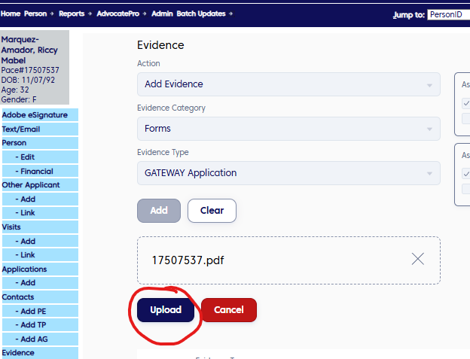

1. You will follow the same steps to upload the 526. They are bulleted below without screen shots, essentially the same steps.
   1. Action = Add Evidence
   2. Evidence Category = Forms
   3. Evidence Type = search 526, select ‘DMA-526 GA’
   4. Select account number associated with 526 under ‘Associated Visits’
   5. Select application you are working under ‘Associate Application’
   6. Click Add, then Browse
   7. Find the 526 in the 526 folder and click ‘Open’
   8. Then, click ‘Upload’
2. Go back to Gateway and click ‘Upload Documents’

1. Select ‘Medical Bills/Documents and scroll down to Step 2.

1. In the Step 2 section, select ‘Application Selection’, check the box for ‘Medical Assistance’, and in the drop down select the first name listed. Then, click ‘Attach’

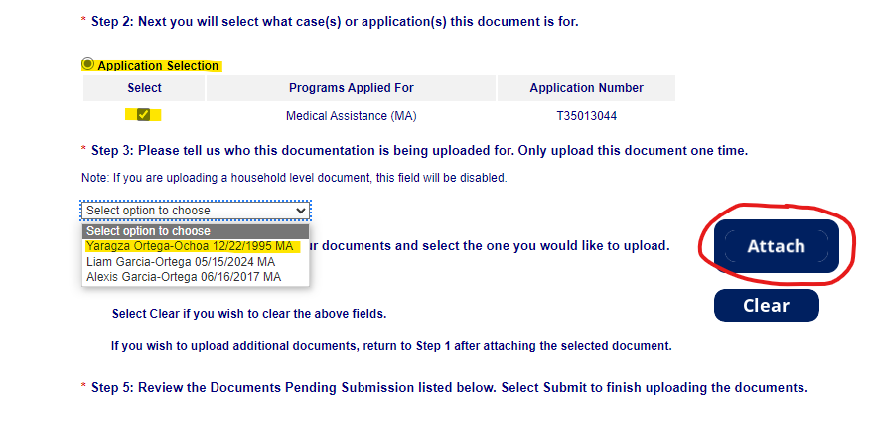

1. After you click ‘Attach’, a window will open to select from a file location. You will select the file folder named ‘526s for GW’, then search for the account number(s) linked to the application you are submitting. Then click ‘Open’.

*\*note: The account number will be included on the assignment spreadsheet, and can also be found in PACE – see step 2 screen shot.*

*\*\*note: You must upload a 526 for every account linked to the application you are submitting.*

1. Once the page reloads, scroll to the bottom of the page to ‘Documents Pending Submission’

1. Go back to PACE, and click on the application name

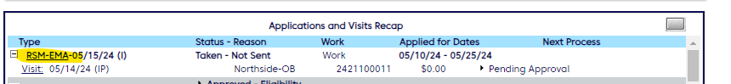

1. Enter the information in the associated fields. Tracking Number is the ‘Case/Application’ number that begins with a T seen in the screen shot for step #15. Status should be changed to ‘Application Submitted’ from the drop down selections, and ‘Sent to Agency Date’ will be the date you are submitting the application in Gateway.

1. Next, select the icon to add a Note

1. Using the information in GW under ‘Documents Pending Submission’ (seen in step 15), begin completing the note for PACE. Select ‘Private’, Role Type = HCR, Note Template type = Custom Notes. Then, use the format in the note below to standardize your notes, but Do Not save your note yet.

*\*If application is not EMA, your note will only be the first line of the note below, then go to step #22*

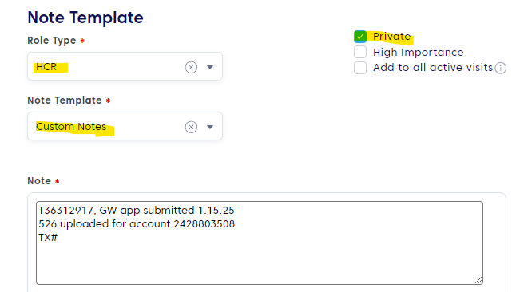

1. Go back to Gateway, and click ‘Submit’ under the Documents Pending Submission section. Once the page re-loads, scroll to the bottom of the page.

1. At the bottom of the page under History of Documents Upload, you will see the Transaction Number for the document uploaded. Copy and paste that number into the PACE note. Next, copy the note entered and then click ‘Save’

1. Once the User note is crated and saved successfully, close out of the note window

1. Then, click Save in PACE on the Edit Application page

1. On the next page, select Person from the left menu, then you will see the application status has been successfully updated to ‘Pending-Application Submitted’

1. If the application type is RSM or Pregnant Woman, go to step 26. Otherwise, all updates have been made and there are no further steps.

1. For application types RSM or Pregnant Woman, there may be a baby linked to the application. You can identify that in the upper right corner in PACE. The baby will have a recent date of birth.

1. Click the baby name to navigate to the baby’s account in PACE

1. Follow steps 17 and 18 above, and in the Note field paste the note you copied from the mom’s account in PACE, click Save, the close the window. Then, click Save in PACE on the Edit Application page (see step 23)
2. Once the application(s) have been submitted and updated in PACE, you will need check the scorecard and update the application status accordingly.
3. Select Classic Scorecard.

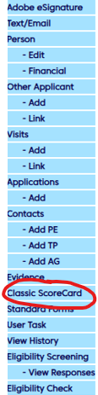

1. Select the  Hyperlink next to the State Application that the HCR updated to Application Submitted. This will open up the application Evidence Scorecard

1. Next you will need to review the **Personal and Financial** evidence scorecard only.

1. If there are **NO** Personal or Financial evidence listed, or the evidence is listed as **Received or Submitted:**

1. Go back to the Person Screen and select the Date hyperlink
2. This opens the Status Agency Page.
3. Under the Select Result drop down, select **Scorecard Review Completed-Documents on File**
4. Add the **Scorecard review Completed-Documents on File** canned note
5. Select **SAVE - NOTE: this is what you will do for ALL application types of Pregnant Woman, RSM, and RSM-Baby.**

1. Next, find the note template in the screen shot below.

1. The application status will update from Application Submitted to Patient Outreach-Scorecard Review Completed-Documents on File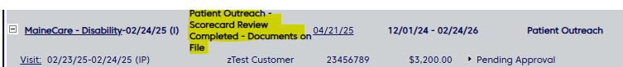
2. If there are Personal and/or Financial evidence listed as **Outstanding – NOTE: These steps only applies to AMN and LIM application types.**

1. Go back to the Person Screen and select the Date Hyperlink



1. This opens the Status Agency Page.
2. Under the Select Result drop down, select **Scorecard Review Completed-Need Evidence**
3. Add the **Scorecard Review Completed-Need Evidence** canned note. In the Free Text box, detail the evidence needed.
4. Select **SAVE**

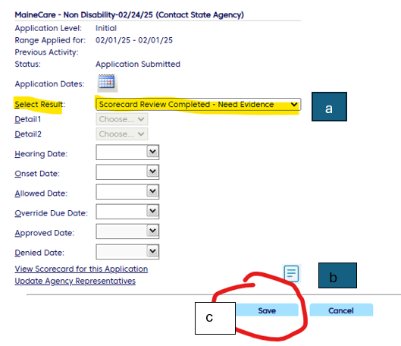

1. Next, find the note template in the screen shot below. In the free form field, type the types of evidence outstanding (found on step 46).

1. The application status will update from Application Submitted to Patient Outreach-Scorecard Review Completed-Need Evidence

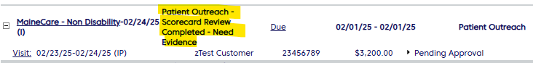

QUICK TIPS

#2 – If there is no User Name or Password listed, use the format username: CHI(pace#), password: (pace#)CHi to log into GW. If that format works, click ‘Edit’ under Person on the left menu, then add the User ID and Password, and click ‘Save’. Then, resume step #2 above.

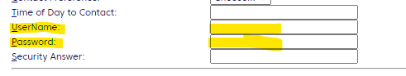

#6 – If this page loads, click “May Applications” which will then allow you to resume step #6.

